EC2

Types of EC2 Instances:

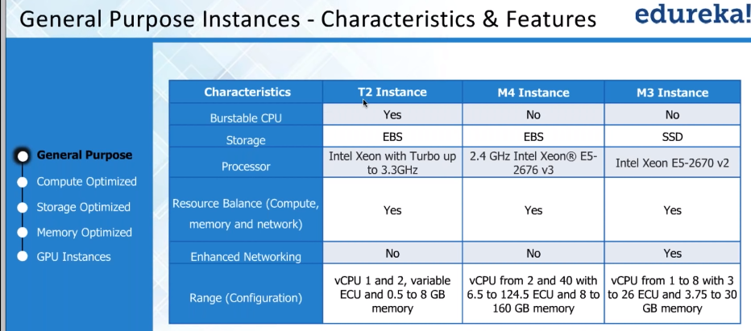



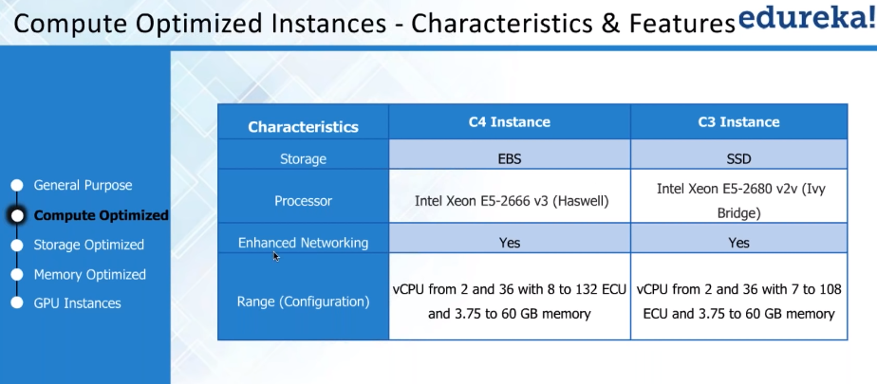



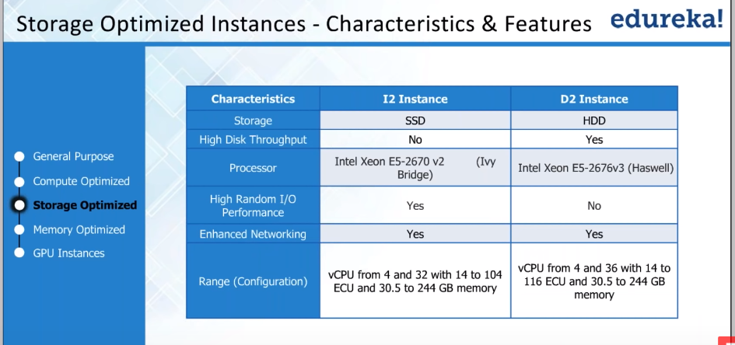

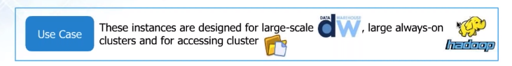

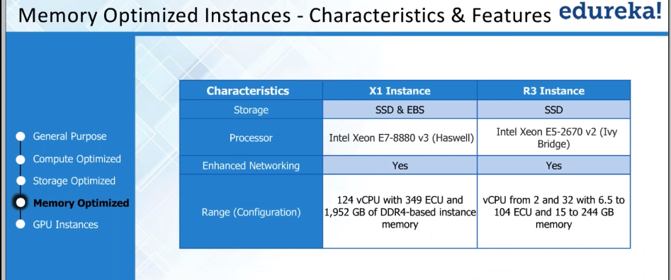

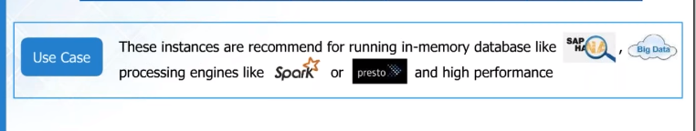

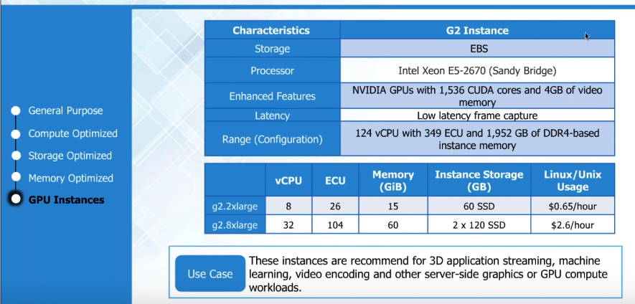

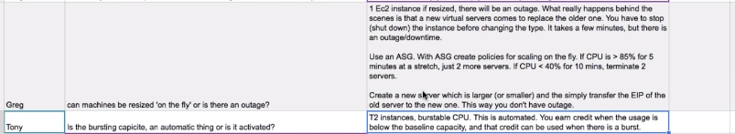

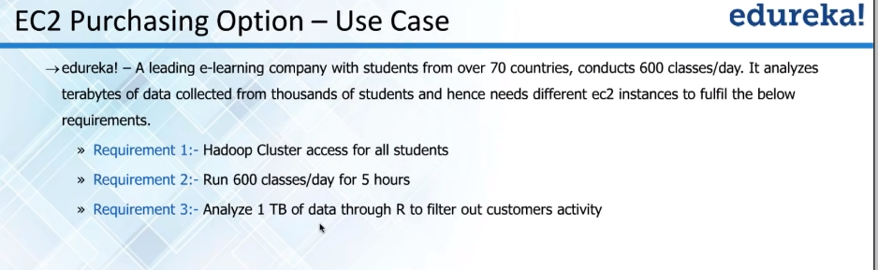

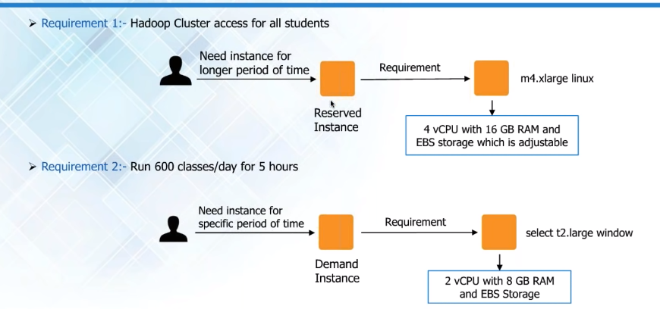

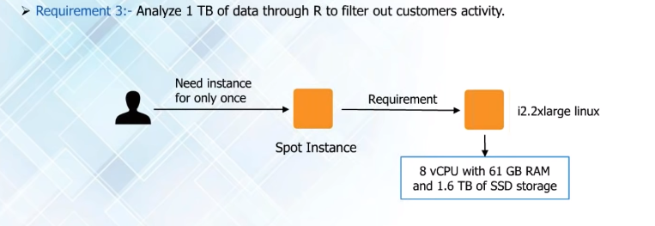

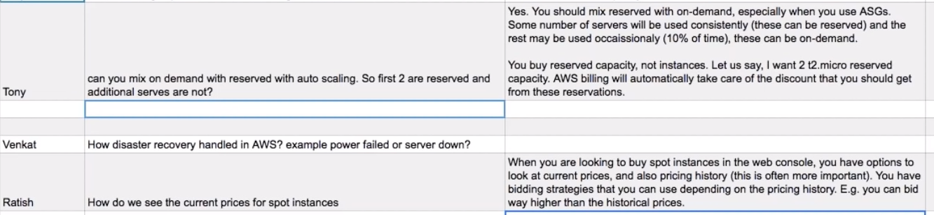

PROJECT

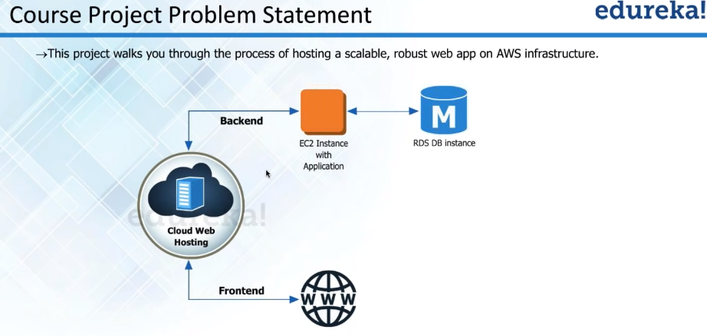

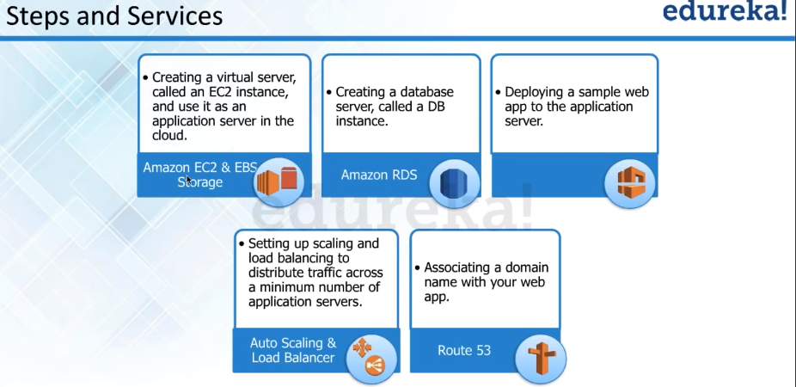

Note : When you stop a server then public IP address associated with the server goes back to AWS and in case if a web page is hosted on that server it will not work. In those scenarios you should always go with elastic IP address. The elastic IP will be assigned to your AWS account and you will be needed to align it to any EC2 server created under your account. Open the elastic IP go to action tab and associate the Elastic IP to any of the instances.

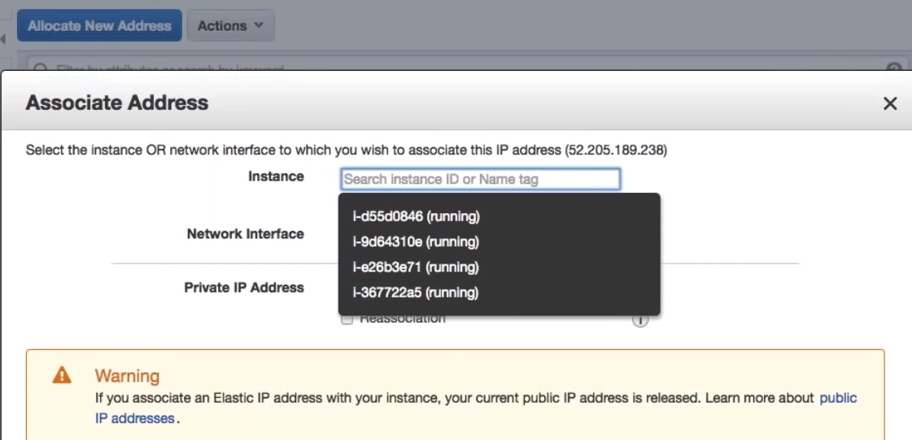

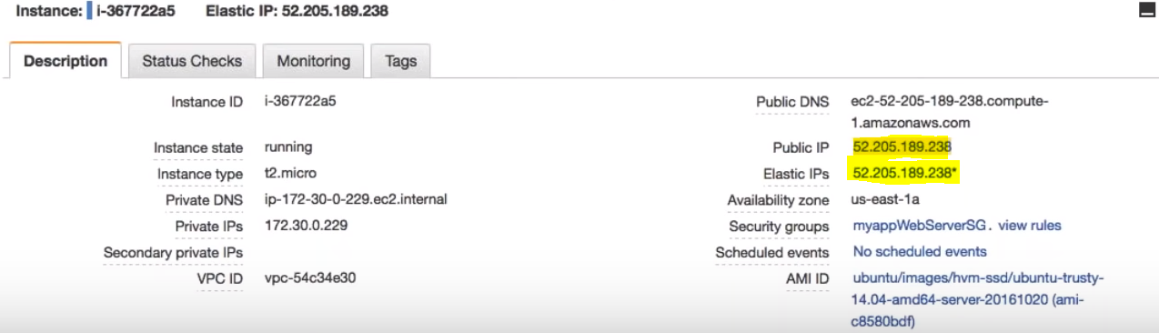

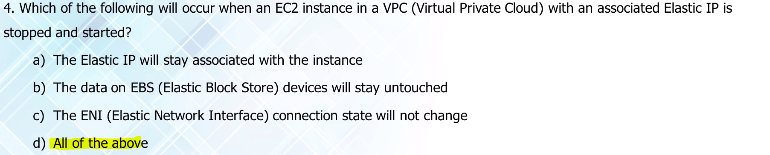

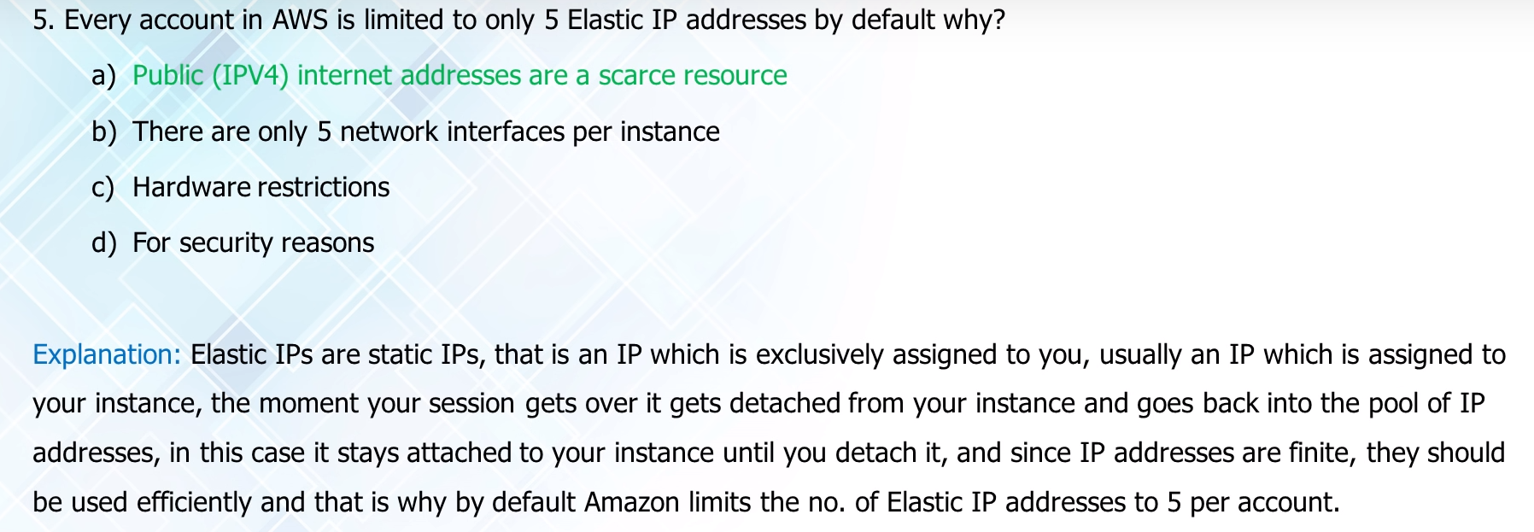

What happens when content is not present at an edge location and a request is made to it in AWS

Cloud Front is a **content** delivery system, which caches data to the nearest **edge location** from the user, to reduce latency. If data is **not present at an edge location**, the first time the data may get transferred from the original server, but from the next time, it will be served from the cached **edge.**

What happens to your data when an ec2 instance is terminated?

After you **terminate** an **instance**, it remains visible in **the** console for **a** short while, and then **the** entry is automatically deleted. You can not delete **the terminated stance** entry yourself. This feature is available for both Amazon **EC2 instance** store-backed and Amazon EBS-backed **instances**.

What is edge location in AWS?

An **edge location** is where end users access services **located** at **AWS**. They are **located** in most of the major cities around the world and are specifically used by Cloud Front (CDN) to distribute content to end user to reduce latency. It is like frontend for the service we access which are **located in AWS** cloud.

How do you access data on elastic block storage in AWS?

As of today, the Amazon **Elastic Block** Store (**EBS**) is now open and available to all **EC2** users. **EBS** gives you persistent, high-performance, high-availability **block**-level **storage** which you can attach to a running instance of **EC2**. You can format it and mount it as a file system, or you can **access** the raw **storage** directly.

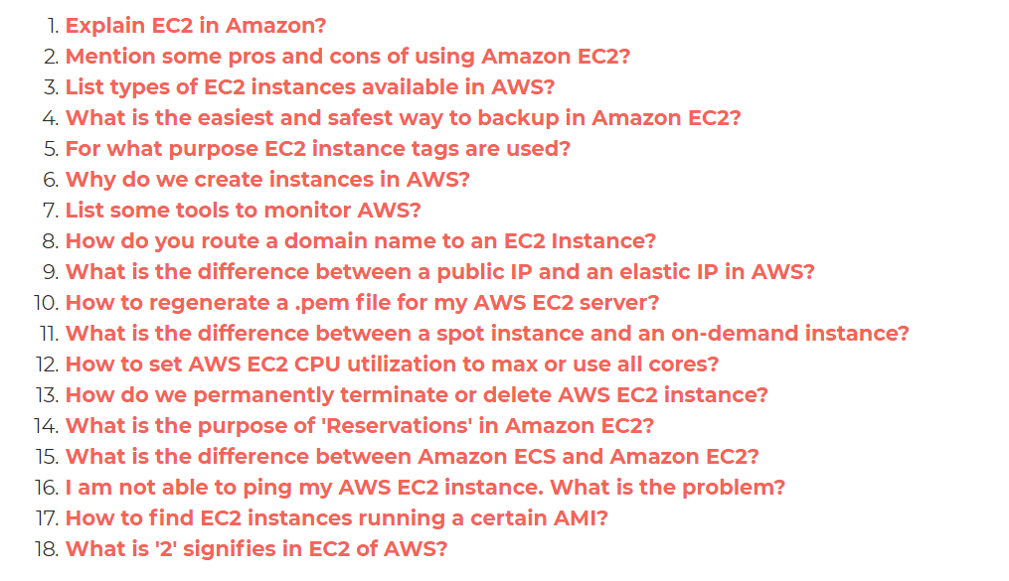

**1. You are planning to build a fleet of EBS-optimized EC2 instances for your new application. Due to security compliance, your organization wants you to encrypt root volume which is used to boot the instances. How can this be achieved?**

**A. Select Encryption option for the root EBS volume while launching EC2 instance.**

**B. Once the EC2 instances are launched, encrypt the root volume using AWS KMS Master Key.**

**C. Root volumes cannot be encrypted. Add another EBS volume with encryption option selected during launch. Once EC2 instances are launched, make encrypted EBS volume as root volume through the console.**

**D. Launch an unencrypted EC2 instance and create a snapshot of the root volume. Make a copy of the snapshot with the encryption option selected and CreateImage using encrypted snapshot. Use this image to launch EC2 instances.**

**Organization XYZ is planning to build an online chat application for their enterprise level collaboration for their employees across the world. They are looking for a single digit latency fully managed database to store and retrieve conversations. What would AWS Database service you recommend?**

**A. AWS DynamoDB**

**B. AWS RDS**

**C. AWS Redshift**

**D. AWS Aurora**

**3. When creating an AWS CloudFront distribution, which of the following is not an origin?**

**A. Elastic Load Balancer**

**B. AWS S3 bucket**

**C. AWS MediaPackage channel endpoint**

**D. AWS Lambda**

**4. Which of the following statements are true with respect to VPC? (choose multiple)**

**A. A subnet can have multiple route tables associated with it.**

**B. A network ACL can be associated with multiple subnets.**

**C. A route with target “local” on the route table can be edited to restrict traffic within VPC.**

**D. Subnet’s IP CIDR block can be same as the VPC CIDR block.**

**5. Organization ABC has a customer base in US and Australia that would be downloading 10s of GBs files from your application. For them to have a better download experience, they decided to use AWS S3 bucket with cross-region replication with the US as source and Australia as the destination. They are using existing unused S3 buckets and had setup cross-region replication successfully. However, when files uploaded to US bucket, they are not being replicated to Australia bucket. What could be the reason?**

**A. Versioning is not enabled on the source and destination buckets.**

**B. Encryption is not enabled on the source and destination buckets.**

**C. Source bucket has a policy with DENY and role used for replication is not excluded from DENY.**

**D. Destination bucket’s default CORS policy does not have source bucket added as the origin.**

**6. Which of the following is not a category in AWS Trusted Advisor service checks?**

**A. Cost Optimization**

**B. Fault Tolerance**

**C. Service Limits**

**D. Network Optimization**

**7. Your organization is building a collaboration platform for which they chose AWS EC2 for web and application servers and MySQL RDS instance as the database. Due to the nature of the traffic to the application, they would like to increase the number of connections to RDS instance. How can this be achieved?**

**A. Login to RDS instance and modify database config file under /etc/mysql/my.cnf**

**B. Create a new parameter group, attach it to DB instance and change the setting.**

**C. Create a new option group, attach it to DB instance and change the setting.**

**D. Modify setting in default options group attached to DB instance.**

**You will be launching and terminating EC2 instances on need basis for your workloads. You need to run some shell scripts and perform certain checks connecting to AWS S3 bucket when the instance is getting launched. Which of the following options will allow performing any tasks during launch? (Choose multiple)**

1. **Use Instance user data for shell scripts.**
2. **Use Instance metadata for shell scripts.**
3. **Use AutoScaling Group lifecycle hooks and trigger AWS Lambda function through CloudWatch events.**
4. **Use Placement Groups and set “InstanceLaunch” state to trigger AWS Lambda functions.**

**Your organization has an AWS setup and planning to build Single Sign-On for users to authenticate with on-premise Microsoft Active Directory Federation Services (ADFS) and let users log in to AWS console using AWS STS Enterprise Identity Federation. Which of the following service do you need to call from AWS STS service after you authenticate with your on-premise?**

**A. AssumeRoleWithSAML**

**B. GetFederationToken**

**C. AssumeRoleWithWebIdentity**

**D. GetCallerIdentity**

**10. How many VPCs can an Internet Gateway be attached to at any given time?**

**A. 2**

**B. 5**

**C. 1**

**D. By default 1. But it can be attached to any VPC peered with its belonging VPC.**

**11. Your organization was planning to develop a web application on AWS EC2. Application admin was tasked to perform AWS setup required to spin EC2 instance inside an existing private VPC. He/she has created a subnet and wants to ensure no other subnets in the VPC can communicate with your subnet except for the specific IP address. So he/she created a new route table and associated with the new subnet. When he/she was trying to delete the route with the target as local, there is no option to delete the route. What could have caused this behavior?**

A. Policy attached to IAM user does not have access to remove routes.

B. A route with the target as local cannot be deleted.

C. You cannot add/delete routes when associated with the subnet. Remove associated, add/delete routes and associate again with the subnet.

D. There must be at least one route on the route table. Add a new route to enable delete option on existing routes.

**12. Which of the following are not backup and restore solutions provided by AWS? (choose multiple)**

A. AWS Elastic Block Store

B. AWS Storage Gateway

C. AWS Elastic Beanstalk

D. AWS Database Migration Hub

**E. AWS CloudFormation**

**13. Organization ABC has a requirement to send emails to multiple users from their application deployed on EC2 instance in a private VPC. Email receivers will not be IAM users. You have decided to use AWS Simple Email Service and configured from email address. You are using AWS SES API to send emails from your EC2 instance to multiple users. However, email sending getting failed. Which of the following options could be the reason?**

A. You have not created VPC endpoint for SES service and configured in the route table.

B. AWS SES is in sandbox mode by default which can send emails only to verified email addresses.

C. IAM user of configured from email address does not have access AWS SES to send emails.

D. AWS SES cannot send emails to addresses which are not configured as IAM users. You have to use the SMTP service provided by AWS.

**14. You have configured AWS S3 event notification to send a message to AWS Simple Queue Service whenever an object is deleted. You are performing ReceiveMessage API operation on the AWS SQS queue to receive the S3 delete object message onto AWS EC2 instance. For any successful message operations, you are deleting them from the queue. For failed operations, you are not deleting the messages. You have developed a retry mechanism which reruns the application every 5 minutes for failed RecieveMessage operations. However, you are not receiving the messages again during the rerun. What could have caused this?**

A. AWS SQS deletes the message after it has been read through ReceiveMessage API

B. You are using Long Polling which does not guarantee message delivery.

C. Failed RecieveMessage queue messages are automatically sent to Dead Letter Queues. You need to RecieveMessage from Dead Letter Queue for failed retries.

D. Visibility Timeout on the SQS queue is set to 10 minutes.

**15. You had set up an internal HTTP(S) Elastic Load Balancer to route requests to two EC2 instances inside a private VPC. However, one of the target EC2 instance is showing Unhealthy status. Which of the following options could not be a reason for this?**

A. Port 80/443 is not allowed on EC2 instance’s Security Group from the load balancer.

B. An EC2 instance is in different availability zones than load balancer.

C. The ping path does not exist on the EC2 instance.

**D. The target did not return a successful response code**

**16. Your organization has an existing VPC setup and has a requirement to route any traffic going from VPC to AWS S3 bucket through AWS internal network. So they have created VPC endpoint for S3 and configured to allow traffic for S3 buckets. The application you are developing involves sending traffic to AWS S3 bucket from VPC for which you planned to use a similar approach. You have created a new route table, added route to VPC endpoint and associated route table with your new subnet. However, when you are trying to send a request from EC2 to S3 bucket using AWS CLI, the request is getting failed with 403 access denied errors. What could be causing the failure?**

A. AWS S3 bucket is in the different region than your VPC.

B. EC2 security group outbound rules not allowing traffic to S3 prefix list.

C. VPC endpoint might have a restrictive policy and does not contain the new S3 bucket.

D. S3 bucket CORS configuration does not have EC2 instance as the origin.

**17. You have launched an RDS instance with MySQL database with default configuration for your file sharing application to store all the transactional information. Due to security compliance, your organization wants to encrypt all the databases and storage on the cloud. They approached you to perform this activity on your MySQL RDS database. How can you achieve this?**

A. Copy snapshot from latest snapshot of your RDS instance, select encryption during copy and restore a new DB instance from the newly encrypted snapshot.

B. Stop the RDS instance, modify and select encryption option. Start the RDS instance, it may take a while to start RDS instance as existing data is getting encrypted.

C. Create a case with AWS support to enable encryption for your RDS instance.

**18. Which of the following is an AWS component which consumes resources from your VPC?**

A. Internet Gateway

B. Gateway VPC Endpoints

C. Elastic IP Addresses

D. NAT Gateway

**19. You have successfully set up a VPC peering connection in your account between two VPCs – VPC A and VPC B, each in a different region. When you are trying to make a request from VPC A to VPC B, request getting failed. Which of the following could be a reason?**

A. Cross region peering is not supported in AWS

B. CIDR blocks of both VPCs might be overlapping.

C. Routes not configured in route tables for peering connections.

D. VPC A security group default outbound rules not allowing traffic to VPC B IP range.

**20. Which of the following statements are true in terms of allowing/denying traffic from/to VPC assuming the default rules are not in effect? (choose multiple)**

A. In a Network ACL, for a successful HTTPS connection, add an inbound rule with HTTPS type, IP range in source and ALLOW traffic.

B. In a Network ACL, for a successful HTTPS connection, you must add an inbound rule and outbound rule with HTTPS type, IP range in source and destination respectively and ALLOW traffic.

C. In a Security Group, for a successful HTTPS connection, add an inbound rule with HTTPS type and IP range in the source.

D. In a Security Group, for a successful HTTPS connection, you must add an inbound rule and outbound rule with HTTPS type, IP range in source and destination respectively.

**I have some private servers on my premises, also I have distributed some of my workload on the public cloud, what is this architecture called?**

1. Virtual Private Network
2. Private Cloud
3. Virtual Private Cloud
4. Hybrid Cloud

**What does the following command do with respect to the Amazon EC2 security groups?**

**ec2-create-group CreateSecurityGroup**

1. Groups the user created security groups into a new group for easy access.
2. Creates a new security group for use with your account.
3. Creates a new group inside the security group.
4. Creates a new rule inside the security group.

**You have a distributed application that periodically processes large volumes of data across multiple Amazon EC2 Instances. The application is designed to recover gracefully from Amazon EC2 instance failures. You are required to accomplish this task in the most cost effective way.**

**Which of the following will meet your requirements?**

1. Spot Instances
2. Reserved instances
3. Dedicated instances
4. On-Demand instances

**If I want my instance to run on a single-tenant hardware, which value do I have to set the instance’s tenancy attribute to?**

1. Dedicated
2. Isolated
3. One
4. Reserved

**When will you incur costs with an Elastic IP address (EIP)?**

1. When an EIP is allocated.
2. When it is allocated and associated with a running instance.
3. When it is allocated and associated with a stopped instance.
4. Costs are incurred regardless of whether the EIP is associated with a running instance.

**Are the Reserved Instances available for Multi-AZ Deployments?**

1. Multi-AZ Deployments are only available for Cluster Compute instances types
2. Available for all instance types
3. Only available for M3 instance types
4. D. Not Available for Reserved Instances

**You need to configure an Amazon S3 bucket to serve static assets for your public-facing web application. Which method will ensure that all objects uploaded to the bucket are set to public read?**

1. Set permissions on the object to public read during upload.
2. Configure the bucket policy to set all objects to public read.
3. Use AWS Identity and Access Management roles to set the bucket to public read.
4. Amazon S3 objects default to public read, so no action is needed.

**A customer wants to leverage Amazon Simple Storage Service (S3) and Amazon Glacier as part of their backup and archive infrastructure. The customer plans to use third-party software to support this integration. Which approach will limit the access of the third party software to only the Amazon S3 bucket named “company-backup”?**

1. A custom bucket policy limited to the Amazon S3 API in three Amazon Glacier archive “company-backup”
2. A custom bucket policy limited to the Amazon S3 API in “company-backup”
3. A custom IAM user policy limited to the Amazon S3 API for the Amazon Glacier archive “company-backup”.
4. A custom IAM user policy limited to the Amazon S3 API in “company-backup”

**A customer implemented AWS Storage Gateway with a gateway-cached volume at their main office. An event takes the link between the main and branch office offline. Which methods will enable the branch office to access their data?**

1. Restore by implementing a lifecycle policy on the Amazon S3 bucket.
2. Make an Amazon Glacier Restore API call to load the files into another Amazon S3 bucket within four to six hours.
3. Launch a new AWS Storage Gateway instance AMI in Amazon EC2, and restore from a gateway snapshot.
4. Create an Amazon EBS volume from a gateway snapshot, and mount it to an Amazon EC2 instance.

**When you need to move data over long distances using the internet, for instance across countries or continents to your Amazon S3 bucket, which method or service will you use?**

1. Amazon Glacier
2. Amazon CloudFront
3. Amazon Transfer Acceleration
4. Amazon Snowball